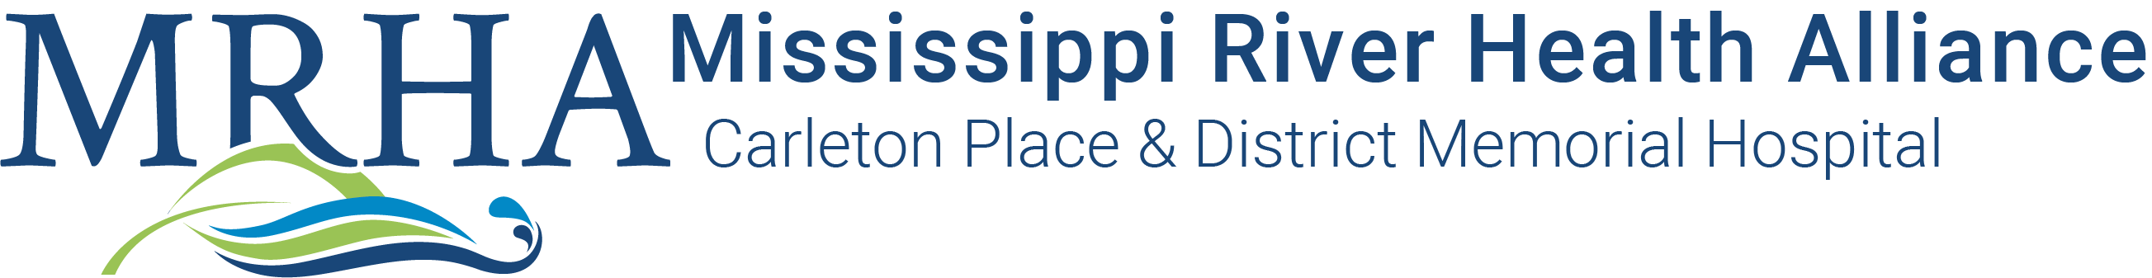

REGISTERED PRACTICAL NURSES(S)
EMERGENCY DEPARTMENT

Full-time & Part-time Position(s)

Almonte General Hospital and Carleton Place & District Memorial Hospital created the Mississippi River Health Alliance (MRHA) in 2016 to formalize their commitment to work together to improve each patient and resident’s overall health care experience through a strong, coordinated system of care. An integrated Senior Team leads the two Hospitals, as well as Fairview Manor and Lanark County Paramedic Service which are operating divisions of AGH. Over 600 caring staff, physicians and midwives provide excellent primary, acute and long-term care to citizens of Lanark County, West Ottawa and Renfrew County.

The Carleton Place & District Memorial Hospital/MRHA offers:
- Competitive Salaries
- Pension Plan (Healthcare of Ontario Pension Plan – HOOPP)
- Employee and Family Assistance Program
- …and so much more!
The Registered Practical Nurse, provides comprehensive, quality patient and family centered care to meet the identified care needs of patients of varying complexity but with predictable outcomes and manageable responses. The Registered Practical Nurse will provide patient care as per knowledge, skill and ability within their professional scope, conduct and demeanour of practice of an R.P.N. and the standards of care as approved by the College of Nurses of Ontario, while ensuring that the CNO ethical guidelines for behaviour and CNA Code of Ethics is adhered to.

Competencies and Personal Attributes
- Commitment to excellence, quality, and patient/resident safety.
- Demonstrated caring and empathetic attitude.
- Ability to meet all demands of the job, both physical and cognitive
- Ability to work cooperatively and respectfully within a team environment.
- Ability to receive direction and understand and follow policies and procedures.
- Ability to work in a manner that is in compliance with patient/resident and employee safety practices, policies and procedures of the organization.
- Ability to contribute to a work environment that is conducive to the organizations Workplace Violence and Harassment policy.

Mandatory Qualifications
- Registered with the College of Nurses of Ontario
- Registered Practical Nurse diploma
- Current BCLS
- Current RPN Medication Administration Course
- Proficient in Venipuncture and IV initiation
- Excellent interpersonal, oral and written communication skills
- Ability to understand, interpret and carry out verbal and written instructions
- Ability to work effectively within the nursing and inter-professional team
- Demonstrated computer competency

Preferred:
- Two (2) years of recent RPN experience in an Emergency Department
- Experience with clinical documentation in an Electronic Health Record
- Membership in RPNAO and associations related to nursing specialty
- Experience as preceptor

SHIFTS: Days / Evenings / Nights / Weekends (subject to change)

WAGE RANGE: $34.03/hr to $35.97/hr

Qualified candidates are invited to submit their resumes to:
Human Resources careers@mrha.ca

We thank all candidates who apply; only those selected for an interview will be contacted.

If you require accommodation throughout any part of the recruitment process, please contact Human Resources to let us
know how we may assist you.

Mississippi River Health Alliance (MRHA) is committed to fostering a culture of diversity, equity, inclusion and belonging. We believe that embracing diversity in all its forms enriches our workplace and enhances the quality of care we provide to our patients, residents and community. We are dedicated to creating an environment where every individual feels valued, respected and supported regardless of race, ethnicity, gender, sexual orientation, religion, age, ability or background. We aim to create a workplace where everyone can thrive and contribute to our shared mission of providing integrated health care that meets the evolving life-long needs of our communities.

Please note that according to the MRHA Vaccination Policies, all applicants must be fully vaccinated unless they can provide the proof of a valid medical contraindication or exemption on the basis of protected grounds under the Ontario Human Rights Code in order to be considered for any staff or volunteer opportunities. Upon hiring, applicants must provide the proof of either government issued documentation proving they have been fully vaccinated, or present supporting documentation of a valid medical contraindication or exemption under Ontario Human Rights Code.

